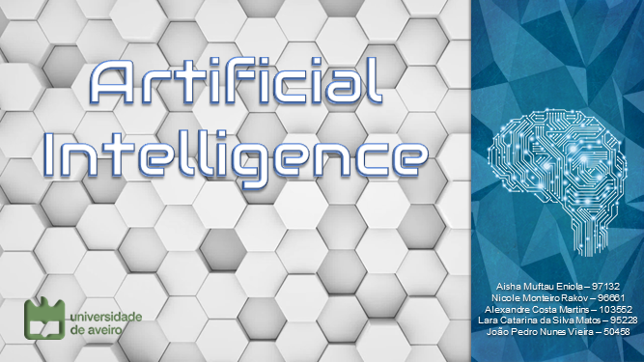

**Bibliography**

Did you like our presentation? Do you wish to learn more about Artificial Intelligence?

Here are some sources of information that you can use to boots up your knowledge on the matter! Stay smart, study hard!

* Artificial Intelligence - Wikipedia

Accessed: October 21, 2021

At: <https://en.wikipedia.org/wiki/Artificial_intelligence>

* Artificial Intelligence: what it is and why it matters (SAS Institute Inc., 2021))

Accessed: October 28, 2021

At: <https://www.sas.com/en_us/insights/analytics/what-is-artificial-intelligence.html>

* Visualizing ANNs with just One Line of Code. – (Towards Data Science , 2018)

Accessed: October 28, 2021

At: <https://towardsdatascience.com/visualizing-artificial-neural-networks-anns-with-just-one-line-of-code-b4233607209e>.

* Artificial Intelligence: Its Scope and Limits – (Fetzer J.H., 1990)

Accessed: October 30, 2021

At: <https://doi.org/10.1007/978-94-009-1900-6_1>

* Artificial Intelligence: A Modern Approach – (S.Russell and P.Norvig - Pearson Series, 4th US ed.)

Accessed: 2021, October 31

At: <https://people.eecs.berkeley.edu/~russell/intro.html>

* Artificial Intelligence - (Harvard Data Science Review, Dick, S., 2019)

Accessed: November 02, 2021

At: <https://doi.org/10.1162/99608f92.92fe150c>

* AI Moonshot Challenge

Accessed: 2021, November 02

At: <https://www.moonshotchallenge.ai/>

* Neural Networks – (IBM Cloud Education, 2020)

Accessed: November 06, 2021

At: <https://www.ibm.com/cloud/learn/neural-networks>.

* Agência Espacial Portuguesa (Portugal Space)

Accessed: 2021, November 03

At: <https://ptspace.pt/pt/home/>

* Hanson Robotics Limited

Accessed: 2021, November 03

<https://www.hansonrobotics.com/sophia/>

* How We Became Instrumentalists (Again): Data Positivism since World War II. Historical Studies of the Natural Sciences (48(5), 673-684)
* Neural Networks and Deep Learning – (Michael A. Nielsen - Determination Press, 2015)

**Videos and documentaries:**

* What Is Artificial Intelligence? Crash Course AI #1 [Video file] – (CrashCourse , 2019, August 09)

Accessed: 2021, October 25

At YouTube: <https://youtu.be/a0_lo_GDcFw>

* How Does AI Work? [Video file] – (Science Please, 2017, April 23).

Accessed: 2021, October 25

At YouTube: <https://youtu.be/L_9OluD0nqw>

* How Neural Networks Work [Video file] – (Code.org., 2020, Dezembro 01)

Accessed: 2021, October 26

At YouTube: <https://youtu.be/JrXazCEACVo>

* Artificial intelligence and algorithms: pros and cons [Video file] – (DW Documentary, 2019, September 26)

Accessed: 2021, October 28

At YouTube: <https://www.youtube.com/watch?v=s0dMTAQM4cw>

* Artificial Intelligence for Breast Cancer Detection [Video file] – (New York University, 2020, January 17)

Accessed: 2021, November 03

At YouTube: <https://www.youtube.com/watch?v=urJ7QEdhP_U>